Run Britain Licence number 2023-46611
Turners Blinds and Shutters Hadleigh 10
Sponsored by Turners Blinds and Shutters
John Chisnall Hadleigh 5
Sponsored by M Chisnall & Son Ltd
5 & 10 mile Road Race (start time 11am)
Junior Fun Run (2k) (start time 10am)
Sponsored by Plant Parts
Sunday 19th November 2023

** FOR SAFETY REASONS ACCESS TO AND FROM THE CARPARK AT THE FOOTBALL CLUB WILL NOT BE PERMITTED BETWEEN 10:00 AND 13:30-PLEASE PARK IN THE TOWN CENTRE CAR PARKS AND LEAVE TIME TO WALK TO RACE HQ AT THE FOOTBALL CLUB (APPROX 10MINS) ***

IMPORTANT

- You should not run if you have any medical condition that would endanger yourself or others by taking part.
- Please try and car share where possible to ease pressure on parking in Hadleigh. Please leave enough time to park and walk to the Football Club (approx. 0.5 mile)
- The carpark at the football club will be closed between 10.00 and 13.30 for safety reasons. Cars will not be permitted up and down Tinkers Lane during this time for runners’ and spectators’ safety. Please use the town centre car parks where possible.

Updated race information

Any last minute updates to the race information will be posted on www.hadleigh-hares.co.uk

Directions to Hadleigh, Suffolk

The start of the Hadleigh 5 / 10 is close to the Hadleigh United Football Ground and both events finish within the ground. The carpark at the football ground will be closed between 10.00 and 13.30 so if you wish to leave early, particularly if you are in the 5 mile race, then you should use one of the local car parks in Magdalen Road or Bridge Street, Hadleigh.
For users of satellite navigation systems, the following post code will take you directly to Magdalen Road car park: IP7 5BB. There is a smaller car park at IP7 5AD.
From Ipswich
- Join the A1071 heading towards Hadleigh
- Continue on A1071 for approx 7 miles
- Turn left onto Lady Lane B1070
- After approx 0.5 miles turn left at the mini roundabout into Magdalen Road
From Colchester
- Join the A12 heading towards Ipswich
- Turn left onto B1070 signposted Hadleigh
- Continue on B1070 for approx 4 miles
- Continue through Benton Street to T junction
- Turn right onto Station Road
- Turn first left into Magdalen Road
From Bury St Edmunds
- Join the A134 heading towards Sudbury
- Turn left onto A1141
- Continue on A1141 for approx 13 miles
- Turn left onto A1071 for approx 200m
- Turn next right onto Gallows Hill B1070
- Continue on B1070 into the High Street
- First left onto Angel Street at the mini roundabout
- After 100m take the second exit at the mini roundabout into Magdalen Road

Car parking

You should use one of the car parks in Hadleigh and walk (approx 0.5 miles) to the ground. The following map shows the location of car parks in Hadleigh. Once you have parked make your way to the High Street and then turn down Duke Street (next to the library). Follow Duke Street for approx 400m and then once you have walked across Toppesfield Bridge turn directly left into Tinker’s Lane. Walk alongside the river and the football ground is at the end of this road (approx 400m).
Please leave plenty of time for parking and walking to the Race HQ.

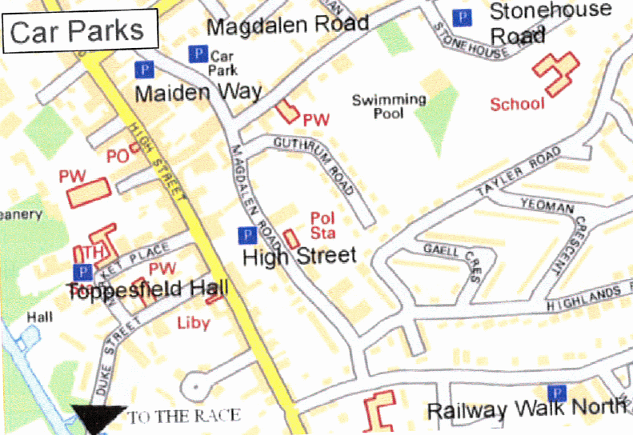
An online map is also available via: https://www.google.com/maps/d/viewer?hl=en&mid=1mQZjaP5iHzezVMcVLQMju4QX6DA&ll=52.038097402025016%2C0.9423299061638772&z=14
Race Number

- Numbers issued on race day from 9.00 until 10.30

Please ensure that you update your details including emergency contact number on the reverse of your number. This is especially important if you have a medical condition which may affect you taking part in the event.
All competitors must wear their race number forward facing during the event.
Please pick up your race number from the Club House and proceed to the finish area, marshals will lead competitors to the race start from here.
If you think you have entered the event but have not received a confirmation email please contact race@hadleigh-hares.co.uk for help.
There will be no entries on the day and you are not able to swap between the race distances.
Event facilities
Changing facilities

Male and female toilets and changing rooms (including showers) are available within the HUFC changing room block adjacent to the clubhouse. Additional toilets are available outside.
Please ensure that you do not enter the main Club House wearing muddy / wet trainers
Refreshments

There is one drinks station serving water at 1.7 miles in the 5-mile race. There are two drinks stations serving water in the 10-mile race: one at 4 miles and one at 7 miles. Water will be available at the finish of the race.
The HUFC Club House tea hut will be open during and after the race (serving hot and cold drinks, sweets and hot food).
There will also be a cake stall, manned by the Chisnall family, raising money for the Melanoma Focus charity.

Secure Luggage Area
There will be a secure luggage area available in the HUFC car park, near to the race finish. This facility is kindly manned by the local Scouts who would appreciate a cash donation.
Race start
The Hadleigh 5 /10 races start together at 11:00 at the small triangle of grass just over Toppesfield Bridge on the main road just outside the football ground (see map below for details). The 10/5 mile races have a start mat and chip timing for the finish.
Runners should gather in the Football Club carpark prior to the race start, from here you be walked to the start by marshals. Please be in position in the carpark by 10:50.
Please note the routes are open to traffic. A Road Closure will be in place for the race start only.
The 5 and 10 mile routes split approximately quarter of a mile after the start. 5 mile runners please make sure you are on the right hand side at the start as you will be turning right whilst 10 mile runners will be going straight on.
The race routes are shown in the map at the end of this information pack. It is the runners’ responsibility to know the route and to follow the signage. The lead bike and marshals at junctions will assist. Distance markers will be available at 1-mile intervals.

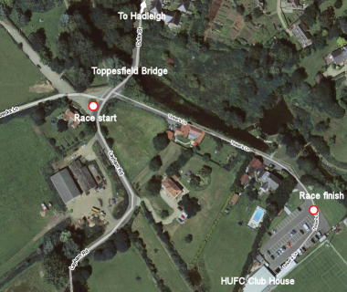

Awards ceremony / results
Three awards ceremonies will be held in the HUFC Club House.
The Junior 2km Fun Run awards ceremony will be held first as soon as the race results are ready, estimated to be at 11.00, followed by the Hadleigh 5 and 10 Mile as a complete set of results become available.
Full race results will be published at https://www.atwevents.co.uk/e/hadleigh-10-and-5-mile-race-10043 and on our web site https://www.hadleigh-hares.co.uk/ after the event.

Trophies
There are three gender categories: Male, Female and Non-Binary

Trophies will be awarded for the Hadleigh 10 and 5 Mile race in the following categories:

- 1st, 2nd and 3rd in each gender category overall
- 1st in each gender category under 40
- 1st in each gender category over 40, 45, 50, 55, 60, 65, 70, 75+
- Team prizes (3 to score) for 1st team in each gender category

Only one trophy will be awarded per individual runner although runners may win a trophy as part of a team as well as an individual.

Rules governing the event
UKA rules
The event will be held under the rules of United Kingdom Athletics. Competitors are advised to familiarise themselves with the rules and regulations that apply to this event otherwise you may be penalised for breaking a rule. If you require more information about the Race Rules please visit http://www.uka.org.uk/competitions/rules.

5 Mile Certificate of Course Accuracy 15/339 10 Mile Certificate of Course Accuracy 15/338

This event is licenced by RunBritain under licence number 2023-46611
Race numbers
You will be issued with one race number which must be clearly visible on your front whilst racing. Please attach the number to your running top with the safety pins provided. The use of race belts is permitted. Please do not cut, fold or mutilate your race number in any way.
Swapping of entries
Please note that the swapping of entries can be done by logging into the Entry Portal https://www.atwevents.co.uk/e/hadleigh-10-and-5-mile-race-10043 by November 12th 2023. Note: You must have registered for an ATW account in order to use this facility. If you do not have an account this can be done when entering the event.

Withdrawal from the race
A runner who retires from a race must not remove his/her race number until he/she has reported to an official as having retired from the race.
Competitors conduct
Competitors and spectators are reminded that they share the Football Ground, parks and the roads with other pedestrians and car users who may not be fully aware of the event.
We ask that you treat both members of the public including other road users, marshals, other competitors, event officials and venue staff with respect. Any use of profanity or aggression towards any other parties will result in immediate disqualification from the event. Please try to remain courteous on the road even if other road users may not offer you the same respect.
Sprint finishes are discouraged.

Headphones
For your safety, the use of headphones, including bone conduction devices, during the race is strictly prohibited. If you are caught using any such equipment whilst taking part in the race, you will be disqualified.
Other information
Race Preparation
We hope your preparations for the race have gone to plan. Information and advice on running safely can be found at http://www.runnersmedicalresource.com. You should be particularly careful about over hydrating during a race.
Medical advice
If you have any known medical condition please ensure you have written all your medical details including any medication taken on the back of your race number, as well as next of kin and emergency contact details and put a small indelible red cross on the front of your number. This is not just an administrative request. It could be a matter of life and death in an emergency. This will only be used in the event of you being involved in an accident.
Whether you have a medical condition or not, if you feel unwell on race day - don't race!

Race volunteers
The races cannot run smoothly without the help of many volunteers. If you have friends or family that will be supporting you during the race, why not ask them if they would be willing to give up a few hours to get involved and help. You do not need any experience or training to become a race marshal – all training will be provided on the day. If you would like to volunteer please contact us by e-mail at races@hadleigh-hares.co.uk
Junior Fun Run 10 am start
There will be no on the day entries to the Fun Run.

Entries can be submitted online at https://www.atwevents.co.uk/e/hadleigh-10-and-5-mile-race-10043 and cost £5.00 plus a 6% booking fee.

Spaces are limited to 100 junior runners so please ensure that you enter early to avoid disappointment.
The start time for the junior race is 10 am. Please make sure children are at the start point by 9.50 am. The Junior 2km Fun Run starts in the grassy picnic area directly adjacent to the river. This is very close to the Hadleigh 10/5 start.
There will be medals for all junior finishers.
Children in the junior race aged 6 and under must be accompanied by an adult at no extra cost.

The age categories are:
1st Boy & Girl overall
1st Boy & Girl U6
1st Boy & Girl U8
1st Boy & Girl U10
1st Boy & Girl U12
1st Boy & Girl U14
1st Boy &Girl U16

Thank you
We would like to thank the generous support of our sponsors who have helped to make this years’ races happen.
Turners Blinds and Shutters Limited www.turnersblinds.co.uk
M Chisnall & Son Limited www.mchisnall-builders.co.uk
Plant Parts https://plantparts.eu/
And finally

The Hadleigh Hares committee would like to wish you well with your race and hope you have a safe and enjoyable event. Please feel free to e-mail us comments, criticisms and suggestions – we are always looking for ways to improve our events.
e-mail: races@hadleigh-hares.co.uk
web site: www.hadleigh-hares.co.uk

This event is licenced by RunBritain under licence number 2023-46611

The Hadleigh 5-Mile Race Route
The Hadleigh 5-Mile Race Route Elevation Profile
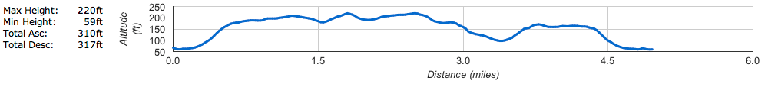
The Hadleigh 10-Mile Race Route
The Hadleigh 10-Mile Race Route Elevation Profile
